Lecture 12
CO1: Apply the knowledge about the concepts of probability and statistics for the computer applications.
CO2: Evaluate the ideas of probability and random variables and various discrete and continuous probability distributions and their properties.
PROBABILITY DISTRIBUTIONS
INTRODUCTION
A probability distribution is essentially an extension of the theory of probability which we have already discussed in the previous unit. This unit introduces the concept of a probability distribution, and to show how the various basic probability distributions (binomial, poisson, and normal) are constructed. All these probability distributions have immensely useful applications and explain a wide variety of business situations which call for computation of desired probabilities.
By the theory of probability
P(H₁) + P(H₂) + …+ P(H_{n}) = 1
This means that the unity probability of a certain event is distributed over a set of disjointed events making up a complete group. In general, a tabular recording of the probabilities of all the possible outcomes that could result if random (chance) experiment is done is called “Probability Distribution”. It is also termed as theoretical frequency distribution.
Frequency Distribution and Probability Distribution
One gets a better idea about a probability distribution by comparing it with a frequency distribution. It may be recalled that the frequency distributions are based on observation and experimentation. For instance, we may study the profits (during a particular period) of the firms in an industry and classify the data into two columns with class intervals for profits in the first column, and corresponding classify frequencies (No. of firms) in the second column.
The probability distribution is also a two-column presentation with the values of the random variable in the first column, and the corresponding probabilities in the second column. These distributions are obtained by expectations on the basis of theoretical or past experience considerations. Thus, probability distributions are related to theoretical or expected frequency distributions.
In the frequency distribution, the class frequencies add up to the total number of observations (N), where as in the case of probability distribution the possible outcomes (probabilities) add up to ‘one’. Like the former, a probability distribution is also described by a curve and has its own mean, dispersion, and skewness.
Let us consider an example of probability distribution. Suppose we toss a fair coin twice, the possible outcomes are shown
Possible Outcomes from Two-toss Experiment of a Fair Coin
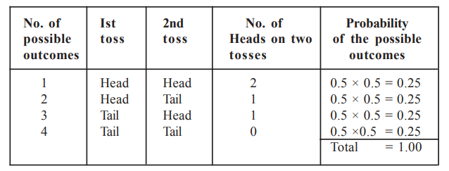
Now we are interested in framing a probability distribution of the possible outcomes of the number of Heads from the two-toss experiment of a fair coin. We would begin by recording any result that did not contain a head, i.e., only the fourth outcome. Next, those outcomes containing only one head, i.e., second and third outcomes, and finally, we would record that the first outcome contains two heads. We recorded the same in to highlight the number of heads contained in each outcome.
Probability Distribution of the Possible No. of Heads from Two-toss Experiment of a Fair Coin
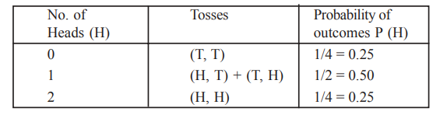
We must note that the above tables are not the real outcome of tossing a fair coin twice. But, it is a theoretical outcome, i.e., it represents the way in which we expect our two-toss experiment of an un-biased coin to behave over time.
TYPES OF PROBABILITY DISTRIBUTION
Probability distributions are broadly classified under two heads:
(i) Discrete Probability Distribution, and
(ii) Continuous Probability Distribution.
i) Discrete Probability Distribution: The discrete probability is allowed to take on only a limited number of values. Consider for example that the probability of having your birthday in a given month is a discrete one, as one can have only 12 possible outcomes representing 12 months of a year.
ii) Continuous Probability Distribution: In a continuous probability distribution, the variable of interest may take on any values within a given range. Suppose we are planning to release water for hydropower generation. Depending on how much water we have in the reservoir viz., whether it is above or below the normal level, we decide on the amount and time of release. The variable indicating the difference between the actual reservoir level and the normal level, can take positive or negative values, integer or otherwise. Moreover, this value is contingent upon the inflow to the reservoir, which in turn is uncertain. This type of random variable which can take an infinite number of values is called a continuous random variable, and the probability distribution of such a variable is called a continuous probability distribution. Before we attempt discrete and continuous probability distributions, the concept of random variable which is central to the theme, needs to be elaborated.
CONCEPT OF RANDOM VARIABLES
A random variable is a variable (numerical quantity) that can take different values as a result of the outcomes of a random experiment. When a random experiment is carried out, the totality of outcomes of the experiment forms a set which is known as sample space of the experiment. Similar to the probability distribution function, a random variable may be discrete or continuous.
The example given in the Introduction; we have seen that the outcomes of the experiment of two-toss of a fair coin were expressed in terms of the number of heads. We found in the example, that H (head) can assume values of 0, 1 and 2 and corresponding to each value, a probability is associated. This uncertain real variable H, which assumes different numerical values depending on the outcomes of an experiment, and to each of whose value a possibility assignment can be made, is known as a random variable. The resulting representation of all the values with their probabilities is termed as the probability distribution of H.
It is customary to present the distribution as shown.
Probability Distribution of No. of Heads
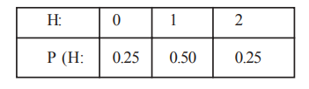
In this case, as we find that H takes only discrete values, the variable H is called a discrete random variable, and the resulting distribution is a discrete probability distribution. The function that specifies the probability distribution of a discrete random variable is called the probability mass function (p.m.f.).
In the above situations, we have seen that the random variable takes a limited number of values. There are certain situations where the variable under consideration may have infinite values. Consider for example, that we are interested in ascertaining the probability distribution of the weight of one kg. coffee packs. We have reasons to believe that the packing process is such that a certain percentage of the packs slightly below one kg., and some packs are above one kg. It is easy to see that it is essentially by chance that the pack will weigh exactly 1 kg., and there are an infinite number of values that the random variable ‘weight’ can take. In such cases, it makes sense to talk of the probability that the weight will be between two values, rather than the probability of the weight taking any specific value. These types of random variables which can take an infinitely large number of values are called continuous random variables, and the resulting distribution is called a continuous probability distribution. The function that specifies the probability distribution of a continuous random variable is called the probability density function (p.d.f.).
Sometimes, for the sake of convenience, a discrete situation with a large number of outcomes is approximated by a continuous distribution. For example, if we find that the demand of a product is a random variable taking values of 1, 2, 3, …to 1,000, it may be worthwhile to treat it as a continuous variable.
In a nutshell, if the random variable is restricted to take only a limited number of values, it is termed as discrete random variable and if it is allowed to take any value within a given range it is termed as continuous random variable.
It should be clear, from the above discussion, that a probability distribution is defined only in the context of a random variable or a function of random variable. Thus in any situation, it is important to identify the relevant random variable and to find the probability distribution to facilitate decision making.
Expected Value of a Random Variable
Expected value is the fundamental idea in the study of probability distributions. For finding the expected value of a discrete random variable, we multiply each value that the random variable can assume by its corresponding probability of occurrence and then sum up all the products. For example to find out the expected value of the discrete random variable (RV) of ‘Daily Visa Cleared’ given:
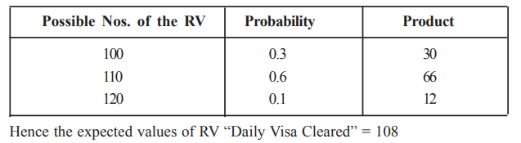
Now, we will examine situations involving discrete random variables and discuss the methods for assessing them.

TEXT BOOKS
- T1 = H. K Dass, Higher Engineering Mathematics, S. Chand Publishers,3rd revised edition.2014.
- T2 = B.S. Grewal, Higher Engineering Mathematics, Khanna Publishers,42th ed.2013, New Delhi.
- T3= N. P. Bali and Manish Goyal, A textbook of engineering Mathematics, Laxmi Publications, Reprint 2008.

REFERENCE BOOKS
- R1=R. K. Jain and S. R. K. Lyenger, Advanced Engineering Mathematics ,3rd Edition Narosa Publishing House ,2004,New Delhi.
- R2 =B. V. Ramana Advanced Engineering Mathematics, McGrawHill, July2006, New Delhi.
- S.P.Gupta,StatisticalMethods,S.Chand&Sons,2017,NewDelhi,ISBN9789351610281Insiders’Guide

Video Lecture :
https://www.youtube.com/watch?v=c06FZ2Yq9rk

